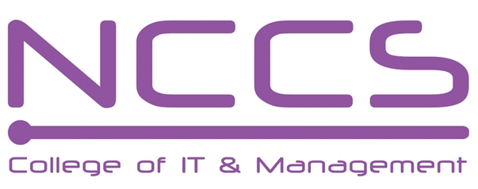
National College of Computer Studies
(NCCS-College of IT & Management)
Final Examination (2021)
BSc.CSIT/First Semester/ CSC 111 : Digital Logic

Candidates are required to answer the questions in their own words as far as practicable.

Full Marks: 60
Pass Marks: 30
Time: 3 Hours
Set A

Attempt any two questions. [2×10=20]
- Define shift register. Explain SISO and PISO shift register with necessary diagram.
- What is synchronous counter? Design a 4-bit synchronous even number up counter using a TFF.
- What are combinational logic circuit design procedure? Design 4-bit gray to binary code conversion circuit.

Attempt any eight questions. [8×5=40]
- Convert (5AA6B.FF6) to decimal, octal and binary.
- Subtract the given number using 2’s complement.
a. 35₁₀-30₁₀ b. - 25₁₀-30₁₀
- Express F (X, Y, Z) =X' Y Z'+(X+Y') (Y+Z+X Y') into Sum of Minterms and Product of Maxterms and simplify the result in SOP using K map.
- Design and explain a full subtractor logic circuit using ROM.
- What is multiplexer? Design and explain block diagram only of 32*1 line multiplexer using minimum number of 8*1 line and 4*1 line multiplexer.
- Design the given Boolean function using PLA.
    - F1(A,B,C)=∑(1,2,3,4,6,7)
    - F2(A,B,C)= ∑ (0,1,2,3,5,7)
- What is race condition in Flip-flop? Convert JK Flip-flop to SR flip-flop.
- Explain the Master-slave S-R flip-flop with logic diagram, truth table and timing diagram.
- Write short notes on (any two):
  - TTL
  - Encode
  - Ring counter

********

Note: Please send your answer sheet to the following e-mail address.
To: csit10batch@nccs.edu.np
CC: er.bishnukc@gmail.com

